**YourMasterpieces**

Technology :  
Codebase : ReactJS + MobX for state management + webpack + Bulma for some components like cards and modals

# Reusable Components:

1. Login Modal
2. Sign Up modal
3. Onboarding modals
4. Artwork Cards
5. Artist Cards
6. Artworks/Artists card section
7. Category Cards and their sections
8. Filter component
9. Blog component
10. Landing page introductory component
11. Share url Dropdown component
12. Followers/following users list modal
13. Error modal
14. Social Login
15. Toolbar
16. Footer
17. Loader : spinner and progress loader for image upload APIs

# Services :

1. Agent : This module consists of the configurable API call function. This function can be called from wherever this module is imported by passing the parameters like request name(ex. post, get,etc ), endpoint , body, and a Boolean for the loader display. This function then returns the response body asynchronously after some conventional error handling.
2. Node server : This server sends build file of the server side rendered project as a response if the request is made from browser. If the request is made from crawler bots , the server redirects those requests to the project which is server side rendered so that they can access meta information in purposes of SEO.
3. SSR project : This is a server side rendered project running on a port that the node server directs crawler bot requests to. This project only throws the meta information to those bots for SEO purposes as they can’t be accessed in server side rendered (SPA) project.

# Standard features developed:

* Landing page with featured products, artists and categories:

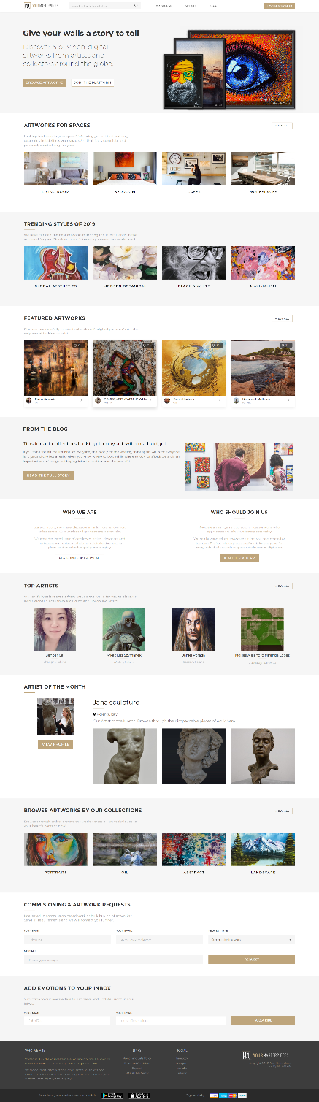

Landing page consists of various components : Artists sections, Artworks sections, Blog section, etc.  
The section components are rendered by passing the props like:

1. Title of the section
2. Description of the section
3. Keyword for View All Button to redirect the user to the list page
4. isColored: If the background color is white this prop is false
5. data: the array of the JSON objects for the respective cards.

Since the project requirement was to keep this page very dynamic, the sections were made very customizable, reusable and maintainable. Dynamicity is maintained using props.

* Email redirected by process: Used for Email verification, reset password. Data with verification token exchanged with the server for authentication purposes.
* product listing with search, filter, pagination.

1. Search results:

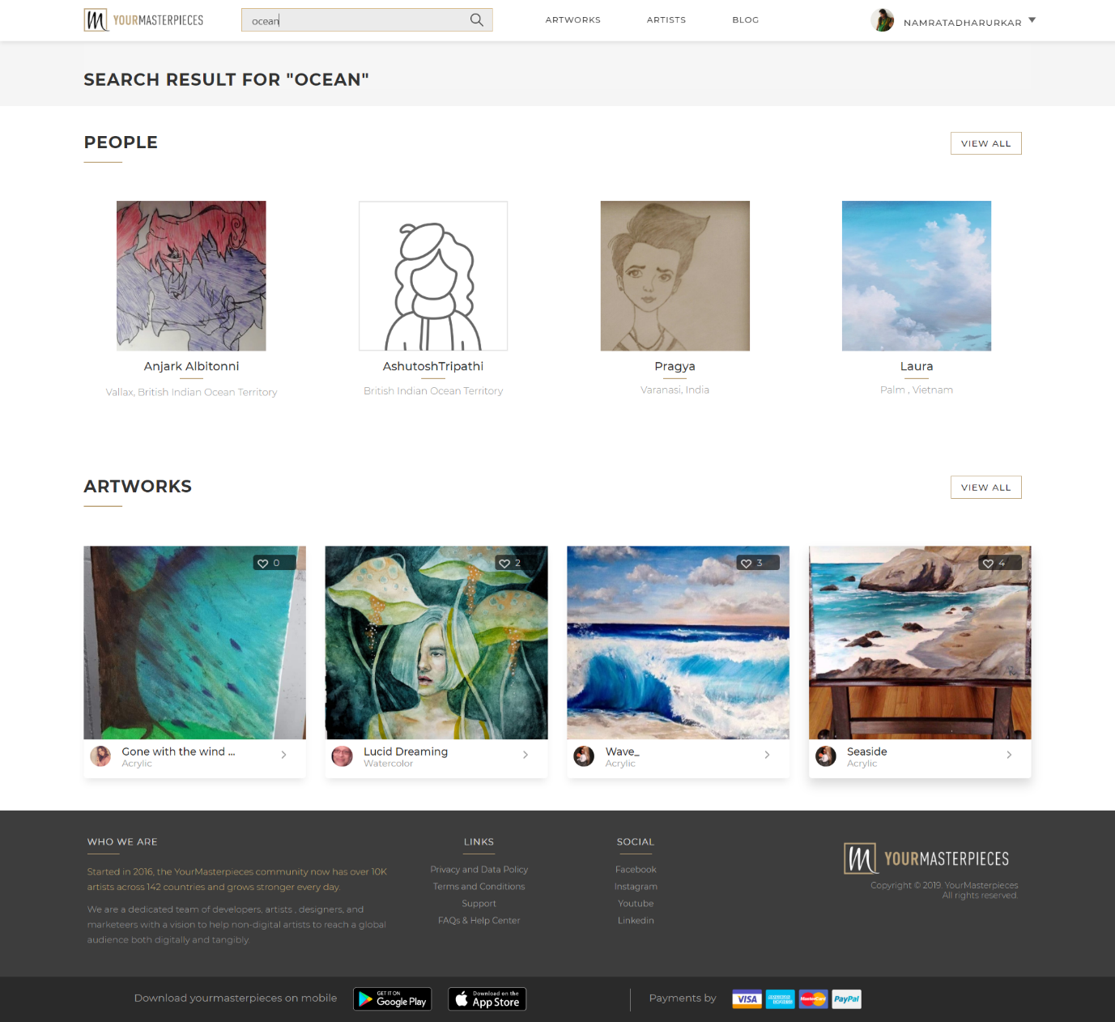

1. Searched artworks : View All list with page scroll pagination

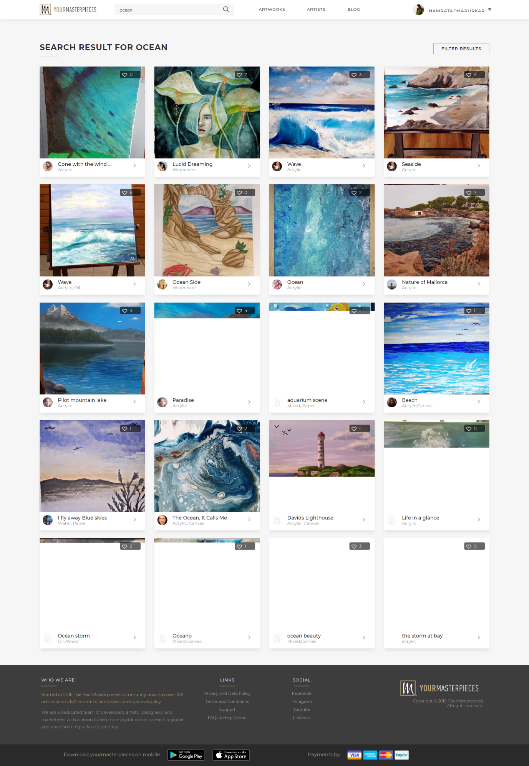

1. Searched People : View all list with pagination

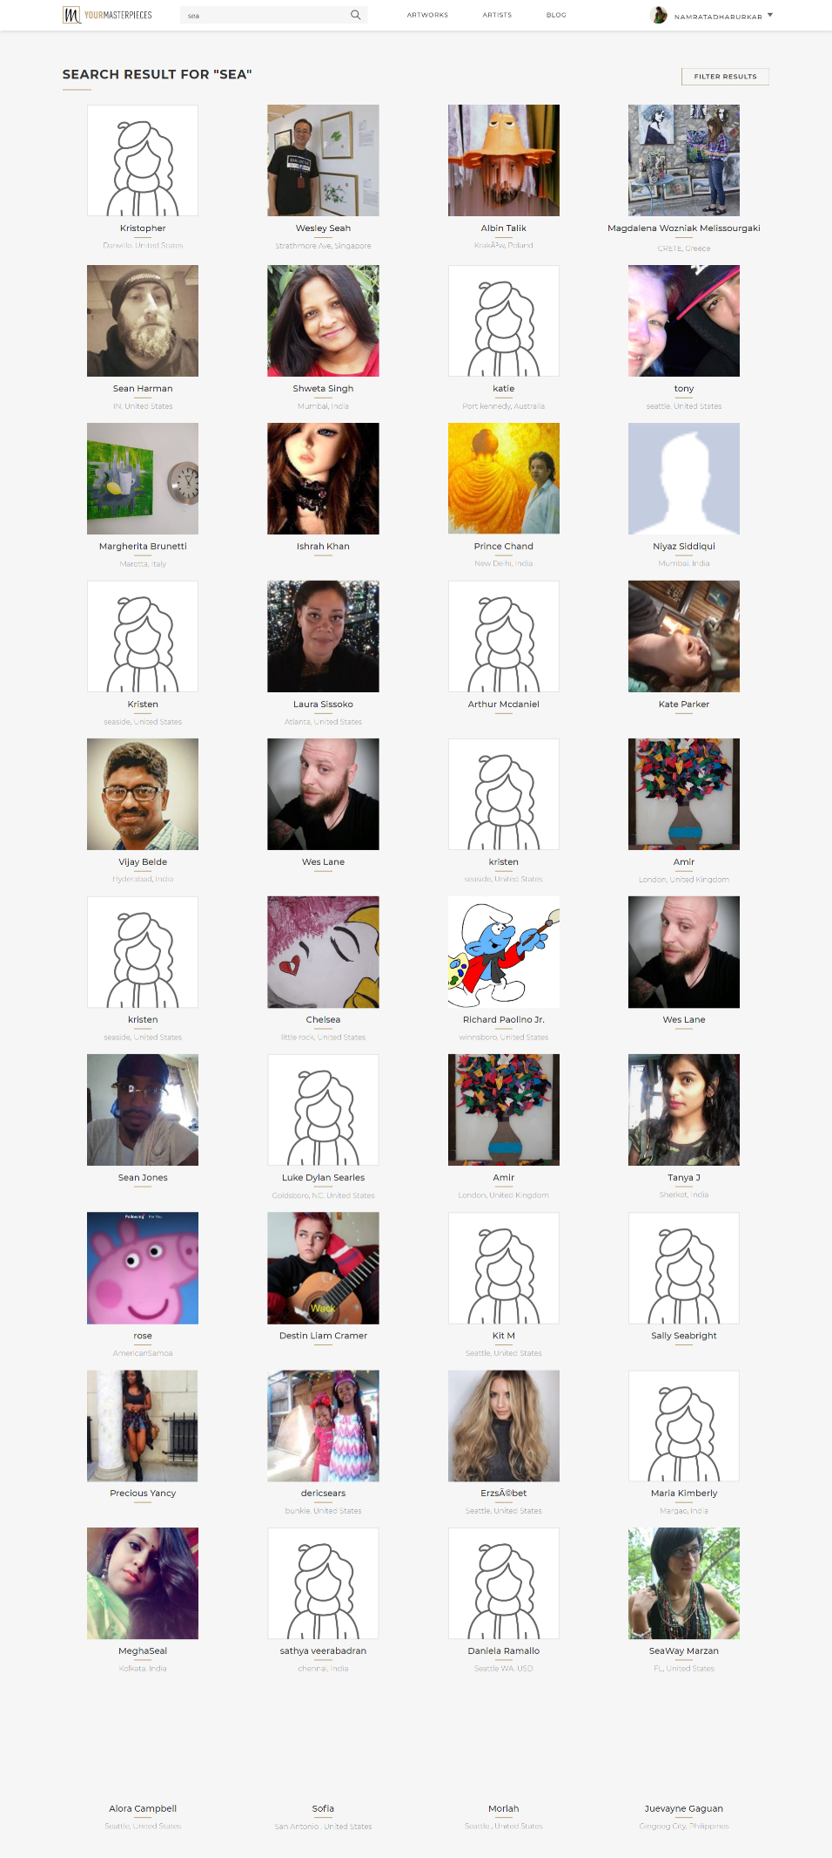

1. Searched Artworks view all list with filters

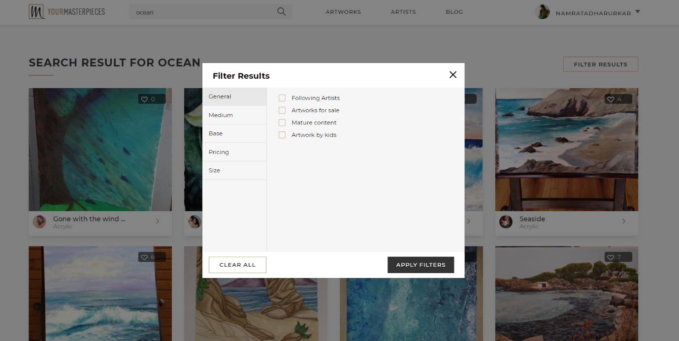

The filter component is configured using an array of the of the JSON objects passed as props if the filters are to be rendered as checkboxes like shown in the above picture.

Configuration Array example=[

{

filterKey: "style", display: "General",

choices: [{ display: "Following Artists", key: "Following Artists" }, { display: "Artworks for sale", key: "Artworks for sale" }, { display: "Mature content", key: "Mature content" }, { display: "Artwork by kids", key: "Artwork by kids" }]

},

{

filterKey: "medium", display: "Medium",

choices: this.props.mediumChoices

},

{

filterKey: "base", display: "Base",

choices:

this.props.baseChoices

},

{

filterKey: "pricing", display: "Pricing",

initial: { currency: localStorage.getItem('preferred_currency') || (false) },

extraProps: {

choices: [

{ min_price: "0", max_price: "50" },

{ min_price: "50", max_price: "100" },

{ min_price: "100", max_price: "1000" },

{ min_price: "1000", max_price: "10000" }

]

}]

To configure the custom filters like pricing and size, functional object returning the required html can be pushed to the configuration array passed as a prop to filter component.

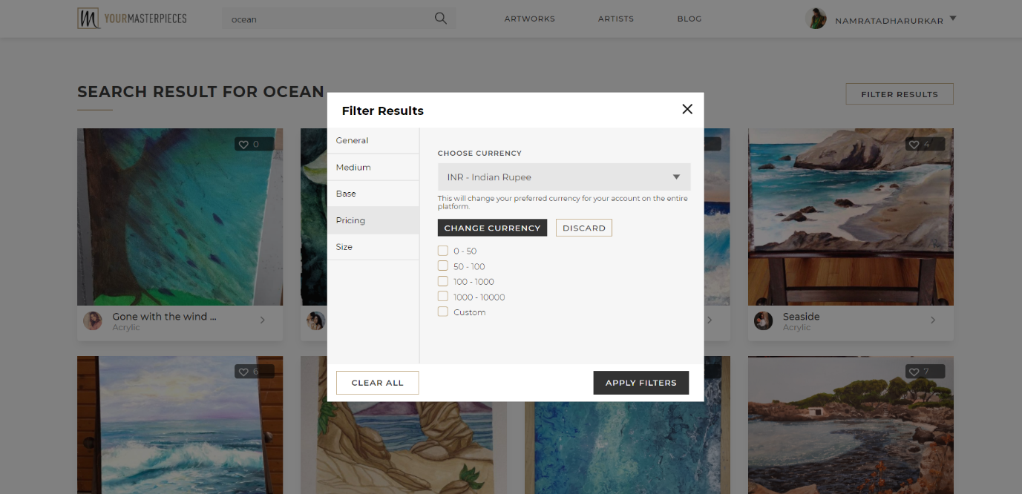



Configuration array example = [customComponent: (props) => {

let {

,

extraProps: { choices },

} = props;

// console.log("customComponent", props)

return <div>

<div className="change-currency mt-25">

<div className="col-md-6">

<label className="mb-0">Currency</label>

<h3 className="currency-text">{currentFilterState.currency}</h3>

</div>

<div className="col-md-6">

<button onClick={handleCurrencyChangeSelection}

className="change-currency-btn pull-right">Change Currency</button>

</div>

</div>

<div className="change-currency-form" style={{ display: (wantsToChangeCurrency) ? "" : "none" }}>

<div className="col-md-12 form-currency">

<label>CHOOSE CURRENCY</label>

<select className="change-currency-select" value={currentFilterState.currency}

onChange={(event) => {

// console.log("Yolo ", event.target.value)

handleCurrencySelection("pricing", event.target.value)

}} >

{

props.Currencies.map((el, idx) =>

<option value={el.key}>{el.display}</option>

)

}

</select>

</div>

</div>

The filter component returns the array of JSON objects with the key value pairs of selected filters to the parent component.

* product detailed view :

Actions :

1. You can send buy requests
2. Like and dislike the artwork.
3. Share it to whatsapp, facebook or twitter and also copy the link to clipboard
4. Report the artwork

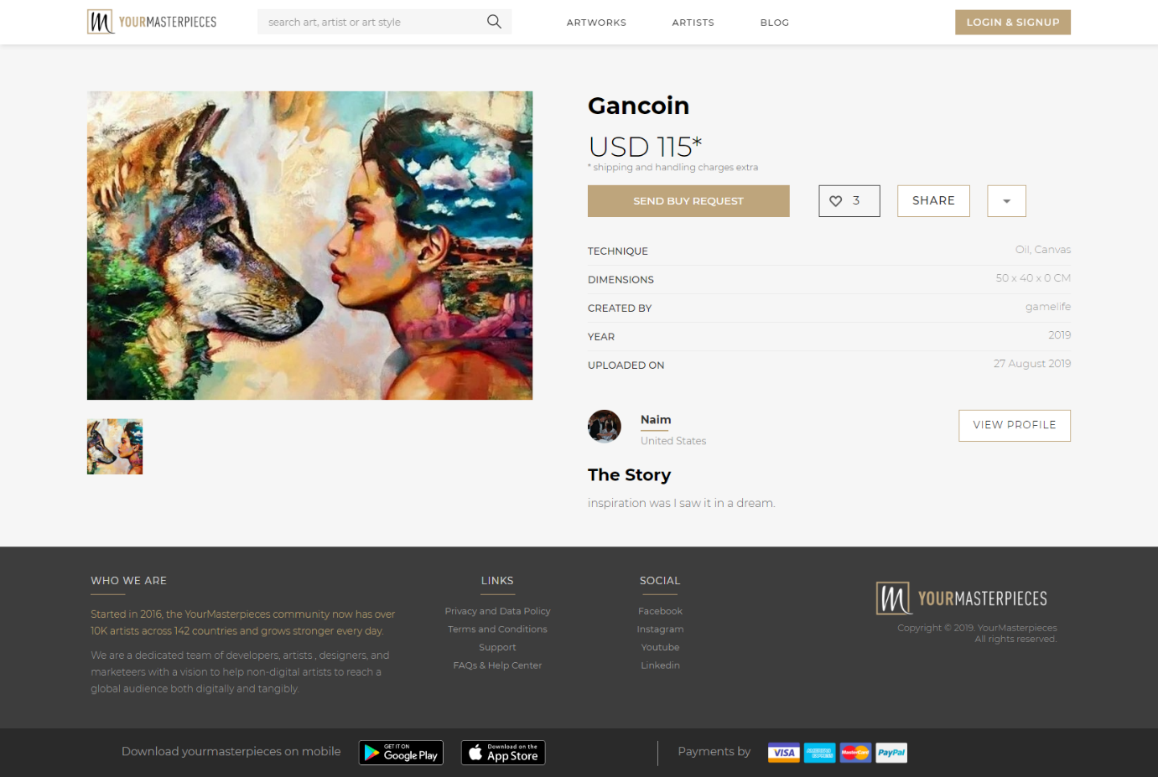

* Profiles:

1. Own profile

Actions :

* 1. Switch the tabs for artworks section and collection section
  2. Redirect to edit profile page
  3. Redirect to upload image page
  4. Share the profile url to facebook, whatsapp, twitter or copy to clipboard
  5. See followers list
  6. See following list

